Exercise proposed during the lesson "Descriptive statistics aggregated data"
Representing data on COVID-19 DEATH IN HEALTHCARE PROFESSIONALS by histogram.

Since the first age class [18.30) is wider than the other classes, it is preferable to report the frequency density on the histogram (although in this specific case this class does not impact the distribution having frequency 0).
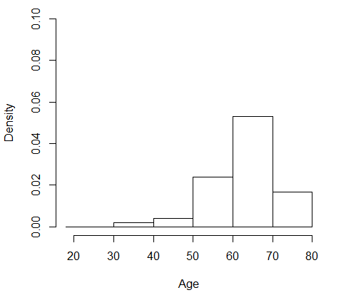
The distribution by age results with negative asymmetry.
The median identified by the graph of the cumulated frequencies is 64 years, the average 62.8 years.
The average is lower than the median because it is more conditioned by the tail on the left (or negative).

