Access to SchoolWork
Connect to the link: https://www.teachingetechnology.it/login.aspx?CODCORSO=P23SMS
At first access use as UserID and Password your university ID number and select “student”.
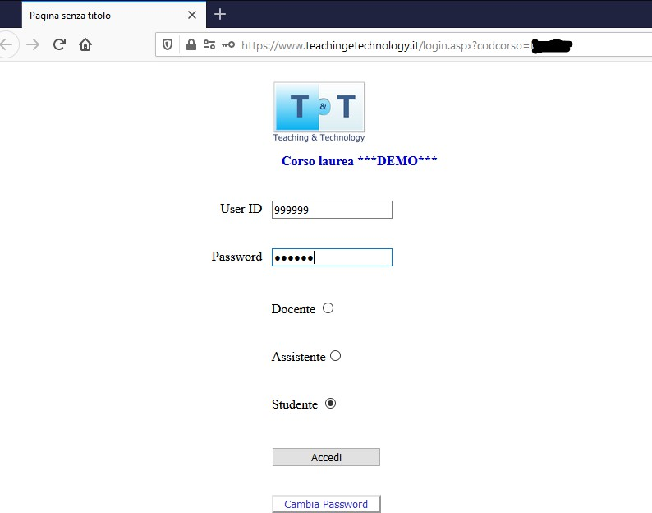
Click on change password and select a new one.
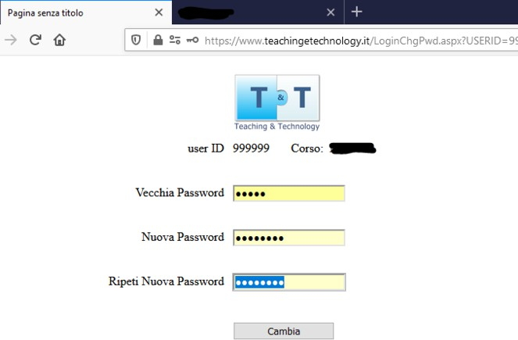

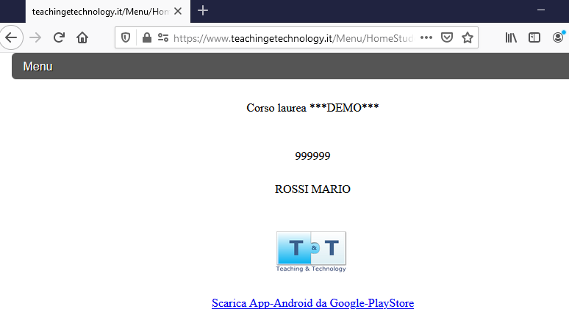
Repeat Login with the new password.

CLERKSHIP ATTENDANCE
From the Menu, select Tirocinio to register your presence in the clerkship activity.
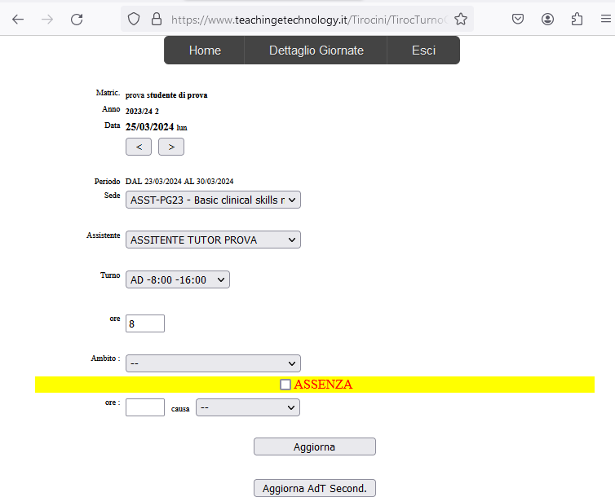
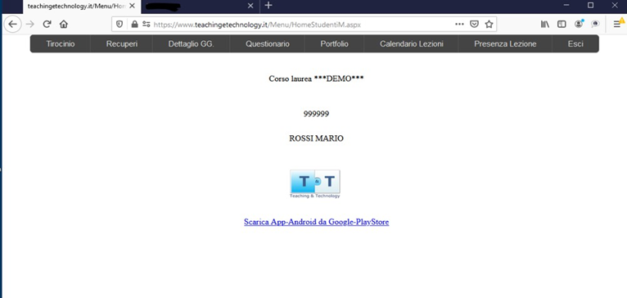

The software proposes the clerkship assigned for the current day by default. You can change the name of the tutor you are being assigned to and the scheduled time. Click “Aggiorna” (Update) to register attendance, which the tutor will later validate.
In case of absence, check the relevant box and set the cause. Click on “Aggiorna”.

If two different clerkships were assigned on the same day (e.g., morning and afternoon), repeat the procedure by selecting “Sede” for each clerkship.

In case you forget, attendance can be recorded up to a maximum of 3 days following, but it is highly advisable to record your presence every day.

RECOVERY OF CLERKSHIP
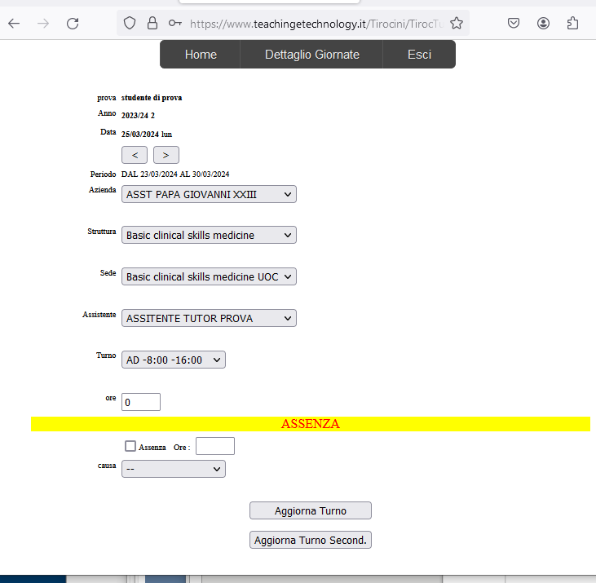
The function displays a summary of one's situation. It shows all completed clerkships, hours, and evaluations of averall activities.

As with clerkship registration, after selecting "struttura, sede, assistente tutor, turno" click on "Aggiorna".

CLERKSHIP DETAIL
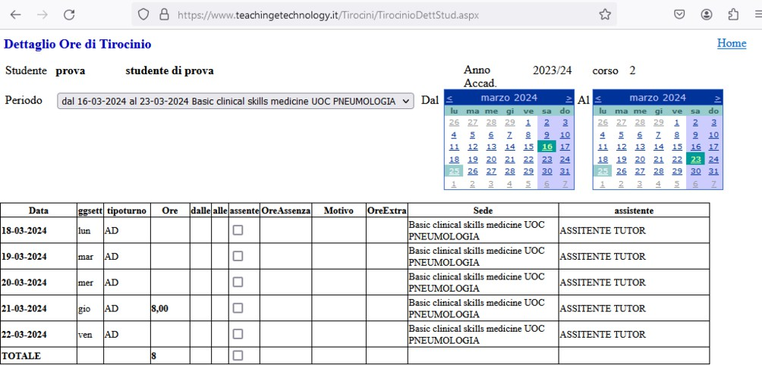
As with clerkship registration, after selecting "struttura, sede, assistente tutor, turno", click on "Aggiorna”:

PORTFOLIO
The function displays a summary of one's situation. All clerkships completed, hours, and activities are displayed.
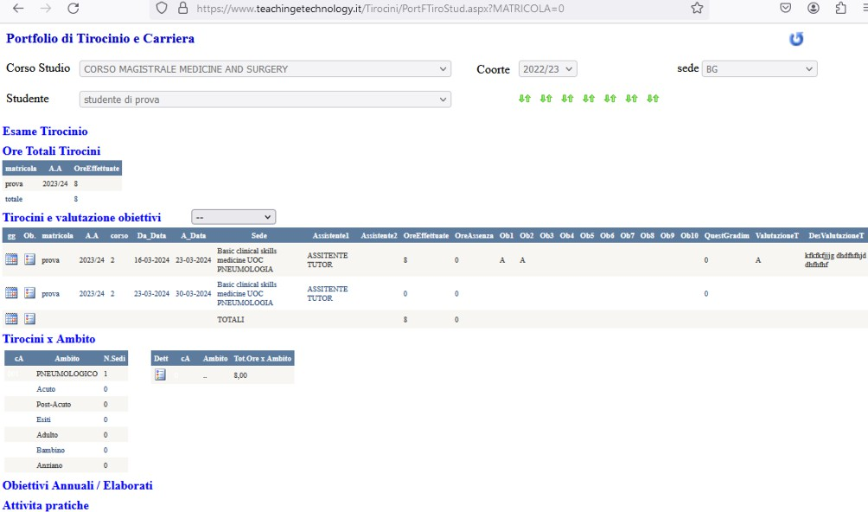

App Android (Apple iPhone not available)
For Android is available the App “SchoolWork” downloadable from PlayStore by clicking on the link on the Home page:

https://play.google.com/store/apps/details?id=b4a.schoolwork

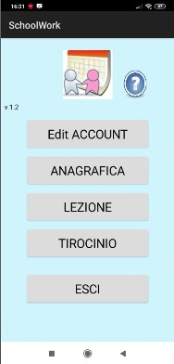
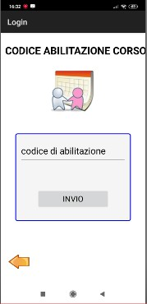
At first use of the App, click on
Edit Account and set the enabling code paezyBI

Then enter the UserId (university ID) and the password set; then click on “Registra”
