STATISTICAL METHODS FOR THE EVALUATION OF
TOURIST SERVICES

- Briefly illustrate the SERVQUAL conceptual framework for GAP5.
The output of SERVQUAL respect to a real case is reported in table 1. Adequately comment on the results and make a graphical representation.

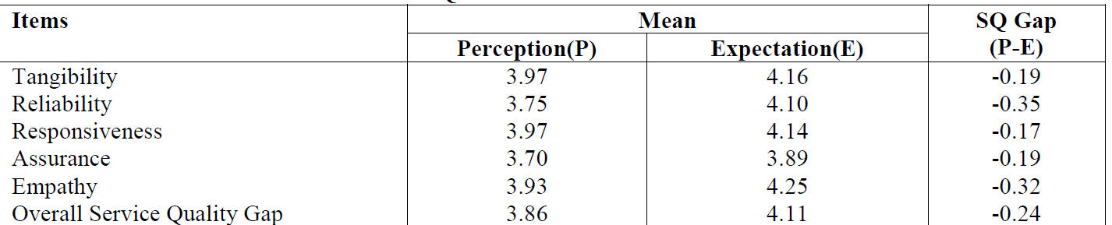
Table 1: output of a SERVQUAL of a real case.

- Criteria to decide the number of the components in PCA.
Table 2 reports the output of a PCA respect to the Eigenvalues. Using all non-common-sense criteria, determine the number of Principal Components to extract.

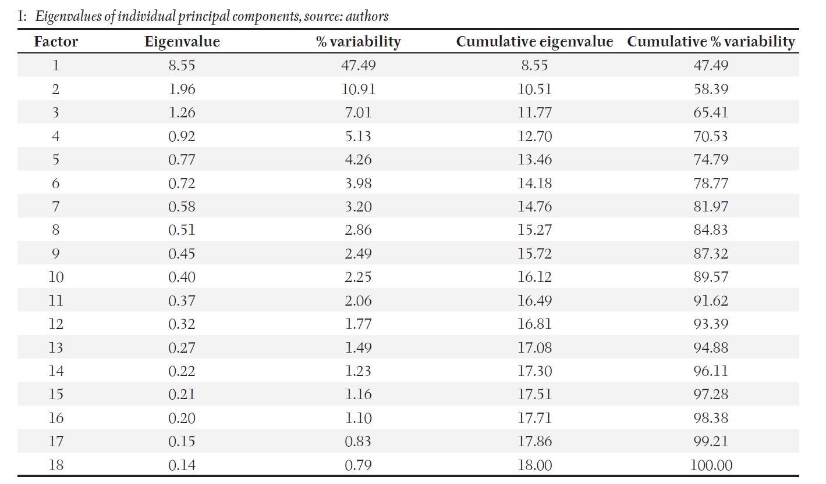
Table 2: output of PCA (real case).

- Reliability of a test and measure to assess it.
Comment on the results reported in Table 3

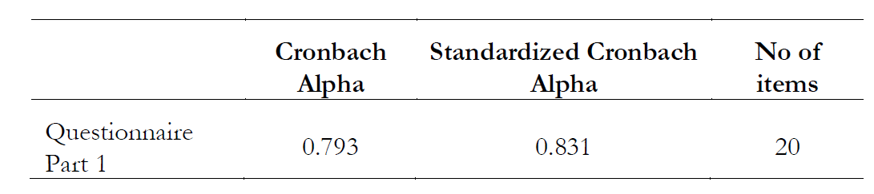
Table 3: Output of the results for reliability of a test.

- Advantages/disadvantages of the LIKERT scale.
Table 4 reports the output of a score based on a 1-5 Likert scale with 20 items. Comment the results of table 4, writing the theoretical minimal and maximum of the Likert scale.
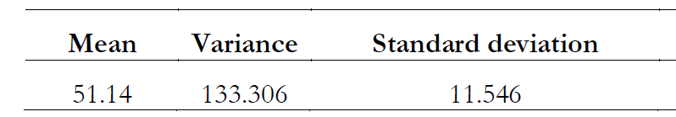
Table 4: results of a Likert scale

